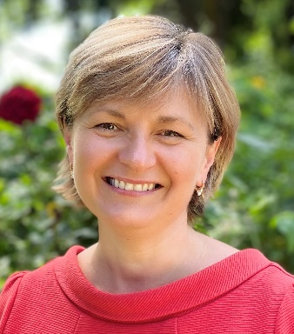
Anna Moon MD PhD
Consultant Orthopaedic Hand Surgeon

Address Spire South Bank Hospital
139 Bath Road
Worcester
WR5 3YB

Email anna.moon@circlehealthpartners.co.uk
Website www.annamoon.co.uk
Practice Manager Ms Jane Green
thehandclinicltd@outlook.com

Office telephone 07340 651908
Full GMC registration 01/06/2005
GMC reference number 6127152
Entry in the Specialist Register 17/06/2005
Speciality Trauma and Orthopaedic Surgery
Special interest Hand and wrist surgery, specific elbow conditions

Education, Training and Career
I graduated from Medical School in 1994 in Kosice, Slovakia. I trained in Trauma and Orthopaedics and Hand Surgery across Europe and in the UK.
I undertook extensive training in hand, wrist and some specific elbow surgery including microsurgery and replantation (reattachment of amputated fingers/hands). My PhD thesis focussed on replantation and microsurgical techniques in hand surgery.
I have been working as a Consultant Orthopaedic Surgeon specializing in hand, wrist and elbow surgery since 2005. I worked in Worcestershire Acute Hospital Trust for 11 years where I ran the Hand Trauma Service for Worcestershire and part of Warwickshire before deciding to work as an Independent Practitioner.
In 2009 I took a sabbatical for 18 months in Abu Dhabi, UAE, where I worked with plastic surgeons on complex hand trauma.
Over the last 20 years I have gained extensive knowledge and experience in hand and wrist surgery.
Teaching, Research and Publications
I regularly deliver teaching sessions to General Practitioners, Physiotherapists and Osteopaths on common hand conditions and treatments.
I have run courses in hand surgery, and have presented at various conferences, both at local, national and international level, and I am a visiting lecturer at Aston University in Birmingham.
Articles I have written have been published in medical journals and I have been involved in research projects, such as “The Molecular Genetics of Dupuytren’s Disease”, and “Cultivated Autologous Osteoblasts and Chondrocytes for Treatment of Non-Union and Chondral Defects”.
I was involved in national hand-surgery-related trials and I ran an international multi-centre drug trial centred on the safety and efficacy of Capsaicin.
Current Clinical and Medico-Legal Activity
Having worked in general Trauma & Orthopaedics for 20 years, I chose to specialise exclusively in hand, wrist and some elbow procedures, which I have done for the last 10 years, having on average 1800 patient episodes per year, which includes consultations and various procedures.
I am a member of BSSH (The British Society for Surgery of the Hand) and WMHS (West Midlands Hand Society). I attend scientific meetings regularly, usually 3-4 times a year to keep myself up to date. In addition I regularly attend various courses and webinars on specific hand surgery related topics.
In 2021 I was involved in reviewing the clinical practice of a colleague in hand surgery, which has consisted of report writing and engaging with the solicitors working on the case.
I attended the Bond Solon courses “Excellence in Report Writing”, “Courtroom Skills”, “Clinical Negligence Essentials Parts 1 & 2”, “Clinical Negligence Update for Expert Witness”, “Masterclass In Report Writing”, “Joint Discussion Between Experts”, and “Personal Injury Essentials”. I also regularly attend Expert Witness meetings and conferences.

